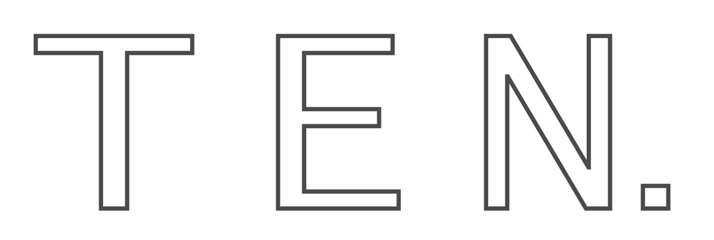

FEBRUARY 2019
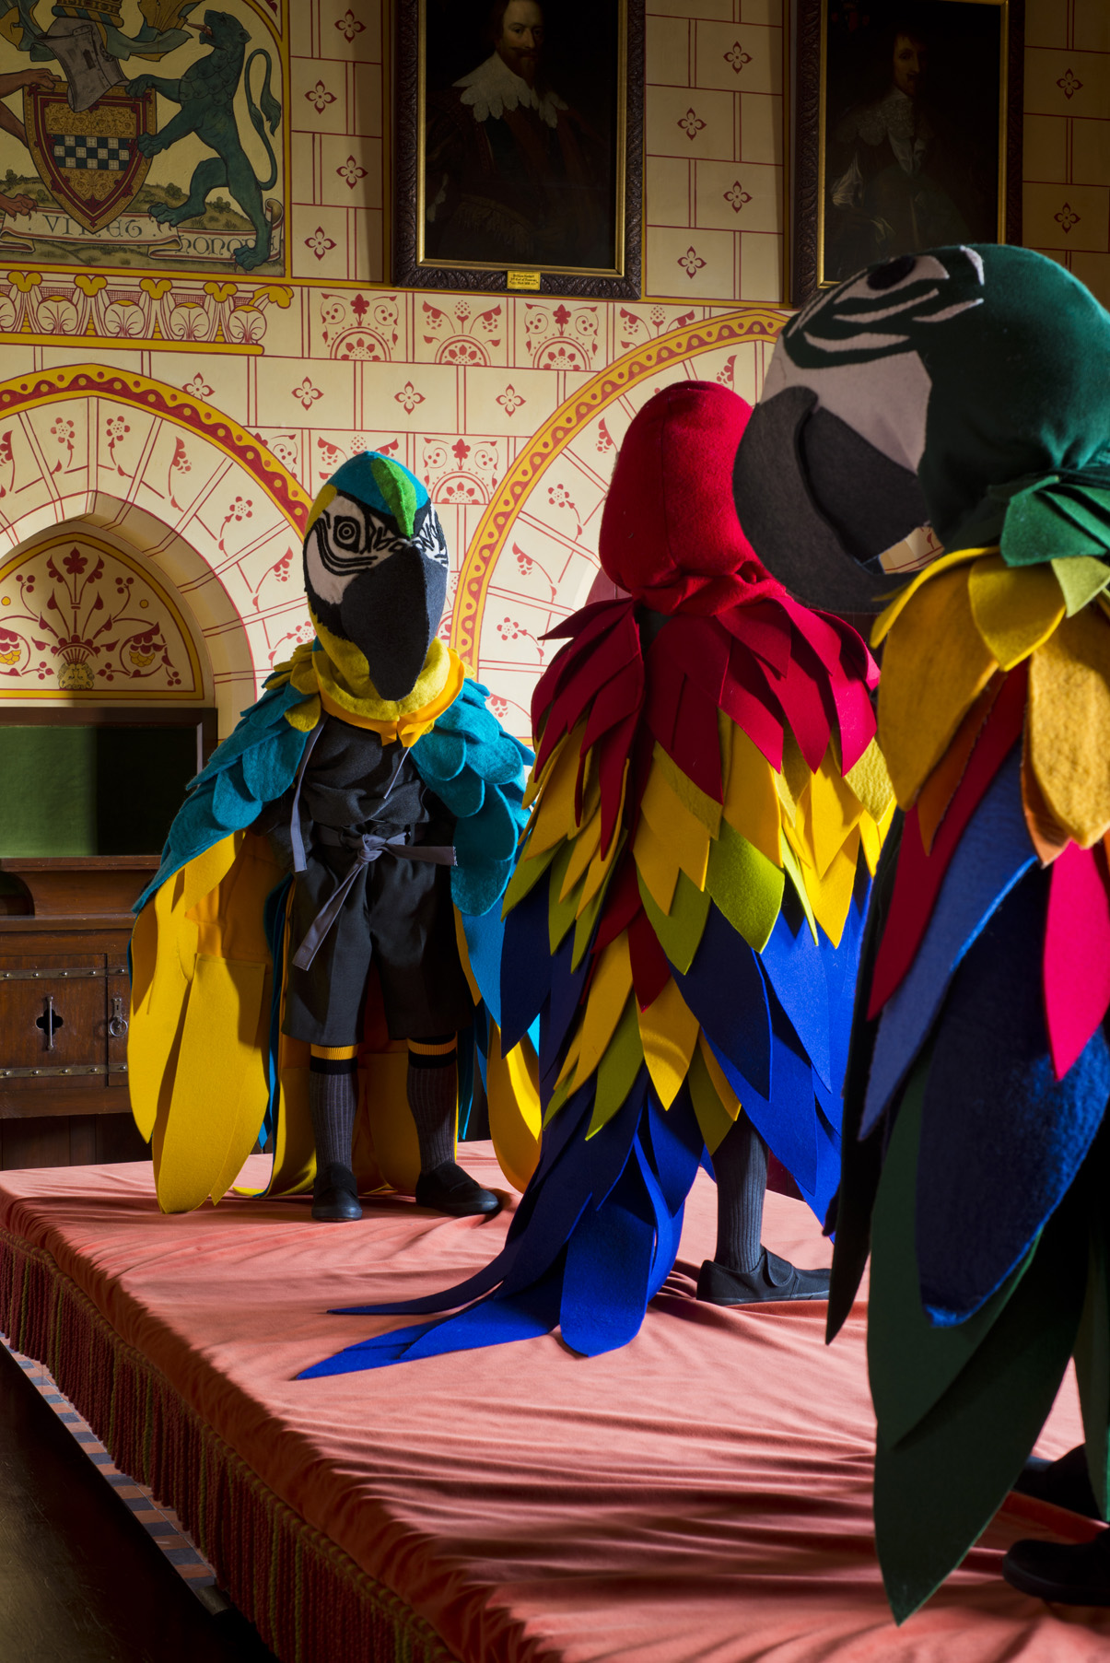
LAURA FORD
SQUATTERS

30 MARCH - 06 MAY 2019

PRESS PREVIEW
FRIDAY 29 MARCH 2.00 - 4.00

OPENING RECEPTION
FRIDAY 29 MARCH 6.30 - 8.00

CASTELL COCH
CARDIFF CF15 7JS

Image: ‘The Little Lords’ © Laura Ford
image courtesy of TEN, photography by Jon
Pountney

TEN presents an exhibition of new works by Laura Ford in partnership with Cadw.

Laura Ford unveils a series of new sculptures inside Wales’ iconic Castell Coch [the Red Castle], as visitors are invited to discover over 20 works created by one of the UK’s leading contemporary artists.

Commissioned by the 3rd Marquess of Bute in 1870s and built by William Burges on the foundations of an original 13thcentury fortress, Castell Coch is either a Gothic fairy tale or a monument to medieval endurance, depending on your romantic inclination. Seen by many as an architectural folly, Laura Ford riffs on the castle’s fabled past to imagine a new generation of anthropomorphic inhabitants.

A meticulously handcrafted rabble of otherworldly interlopers are concealed and revealed within the castle’s architecture as figures appear cloaked, crouched or soaring from the rafters. Ford’s reinterpretation of the folk lore and folk art, which is so intrinsic to the public perception of the castle, takes on a fantastical and sometimes sinister edge. Rendered in bronze, jesmonite and ceramic, and clothed in brilliant swathes of wool and felt, her child-sized figures are inherently tactile. Their postures are pointedly and recognisably human.

Ford imagines a direct conversation between the past and present; one where parrot-children flock to disrupt festivities in the banqueting hall; monkeys run amok in Lady Bute’s chamber and knights are seemingly felled in the courtyard. Each tableau is a testament to Ford’s accomplishments as both a sculptor and storyteller.

The exhibition will be launched by Lord Dafydd Elis-Thomas, Minister for Culture and Sport Friday 29th March. The exhibition is open to the public from 30th March to 6th May 2019.

For further inquiries please contact the gallery at info@gallery-ten.co.uk or at +44.02920 600 495. All images are subject to copyright. Gallery approval must be granted prior to reproduction. Laura Ford is available for interviews in London, and Cat Gardiner is available for English and Welsh language interviews in Cardiff - to arrange, please contact the gallery directly.

Castell Coch opening times: Daily 9.30am - 5.00pm. Admission fees apply

gallery-ten.co.uk
info@gallery-ten.co.uk
+44 [0]29 2060 0495

TEN Home Gallery 143 Donald Street, Cardiff CF24 4TP

Instagram: @TEN @laura_ford_sculpture @cadwcymruwales
#galleryTEN #lauraford #cadw #squattersatcastellcoch

LAURA FORD

IImage: Laura Ford, China Cats, Studio Shot, © Laura Ford, image courtesy of the artist

Laura Ford studied at Bath Academy of Art between 1978-82 including a period at the Cooper Union School of Art, New York. Her tutors included Michael Pennie, Richard Deacon, Nick Pope, Antony Gormley, Peter Randall-Page, Shelagh Cluett and Anish Kapoor. She was included in New Contemporaries in 1982 before joining the postgraduate sculpture course at Chelsea School of Art in London.

While still a student, she participated in the 1983 survey exhibition, The Sculpture Show at The Serpentine and Hayward Galleries alongside artists including, Richard Wentworth, Tony Cragg, David Nash and many of her tutors. 27 years later she participated in The British Art Show 5 alongside a new array of British artists that included Phyllida Barlow, Jeremy Deller, Michael Landy and Susan Hiller, Tracy Emin and Sarah Lucas. In 2005 she represented Wales in the Venice Biennale.

During the intervening years and beyond she has had numerous solo and group shows around the world including 2012 'Days of Judgment', Kulturzentrum Englische Kirche , Galerie Scheffel, Bad Homburg and at The New Art Centre, Roche Court, 2011 Frederik Meijer Gardens & Sculpture Park, Grand Rapids, USA, 2007, 'Rag and Bone', Turner Contemporary, Margate, 2006 'Armour Boys', Royal Scottish Academy, Edinburgh, 2005, Venice Biennale for Wales, 2004, 'Wreckers', Beaconsfield, 2004 'Into My World: Recent British Sculpture', Aldrich Museum of Contemporary Art in Connecticut, USA, London, 2003, 'Headthinkers', Houldsworth Gallery, Cork Street, 2002, 'The Great Indoors', Salamanca Centre of Contemporary Art, Spain, 1998, Camden Arts Centre, London (with Jacqui Poncelet).

Her work is represented in many public collections including; Tate, The Victoria and Albert Museum, Government Art Collection, Potteries Museum, National Museums and Gallery of Wales; Museum of Modern Art, University of Iowa; Arts Council of Great Britain; Contemporary Art Society; Unilever plc; Penguin Books; Oldham Art Gallery, The New Art Gallery Walsall, The Glynn Vivian Art Gallery, The Meijier Gardens, Grand Rapids USA and The Gateway Foundation, St. Louis, as well as numerous private collections.

Her sculptures are faithful representations of fantasy with sometimes bitter sweet and menacing qualities mixed with tenderness. She uses humour and an acute observation of the human condition to engage with wider social and political issues. Her work is intensely crafted but playful, and she has used a range of media to realise her work including, drawing, painting, performance, set design and has increasingly taken on the challenge of public art alongside museum and gallery shows.

'Ford provides us with acutely graphic renditions of human emotion, mental and physical. Her imagery is all about remembering and giving memory clarity.'
- Dr. Penelope Curtis

Cardiff-born Laura Ford lives and works in Camden, alongside her husband, the sculptor Andrew Sabin and their three children.

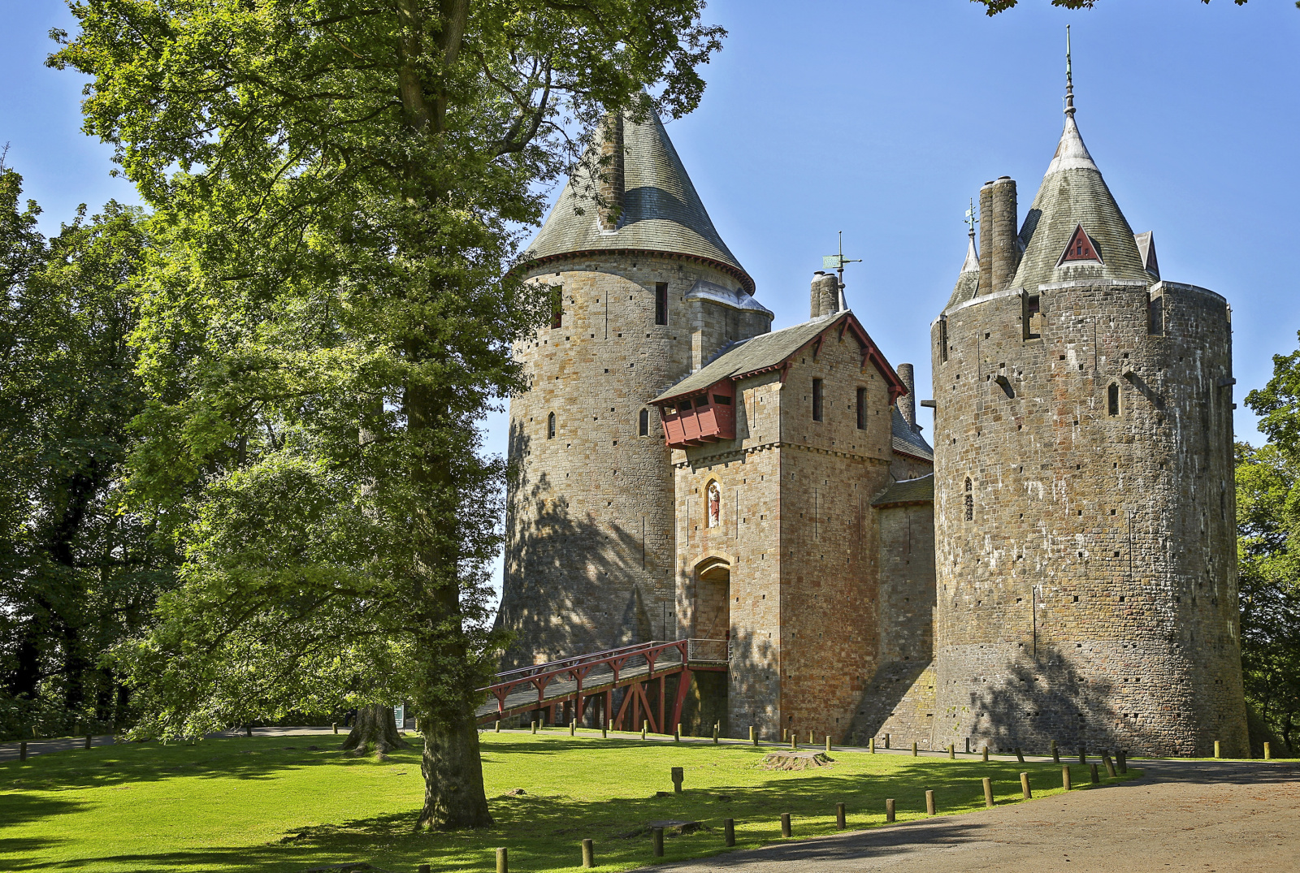

Castell Coch is a 19th-century Gothic Revival castle built above the village of Tongwynlais in Cardiff, South Wales. The first castle on the site was built by the Normans after 1081, to protect the newly conquered town of Cardiff and control the route along the Taff Gorge

While resting on ancient foundations, Castell Coch [Red Castle in Welsh] is relatively modern, the by-product of a vivid Victorian imagination, assisted by untold wealth. The Middle Ages fascinated the Victorians as much as the Victorians fascinate us today. High Gothic was the order of the day.

The ‘eccentric genius’ William Burges was given free rein by his paymaster, John Patrick Crichton-Stuart, the 3rd marquess of Bute, to create a rural retreat to complement the opulence of his main residence, Cardiff Castle. He didn’t hold back. Dazzling ceilings, over-the-top furnishings and furniture were liberally applied.

Detailed architectural drawings still survive today and following Burges’s death in 1881, colleagues faithfully continued work on the interiors for another ten years. The castle was not suitable for, nor was it intended to be, a permanent residence and the family’s visits were infrequent.

Cadw, the Welsh for to keep, is the Welsh Government’s historic environment service working for an accessible and well-protected historic environment.

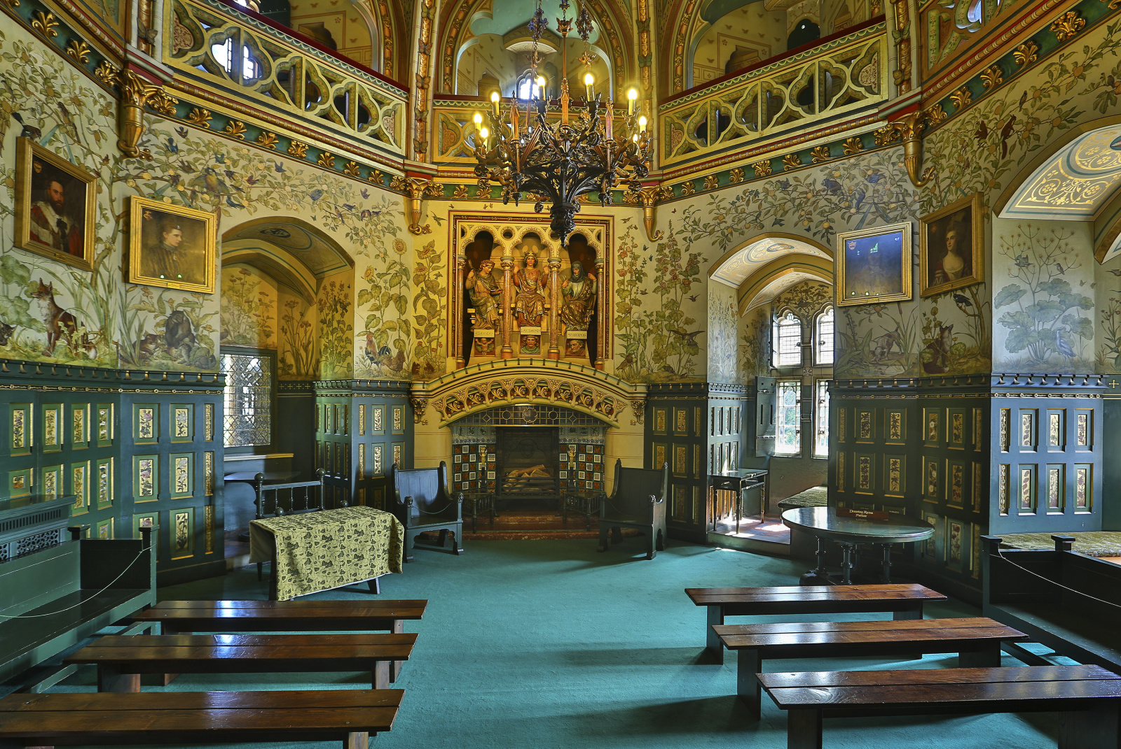

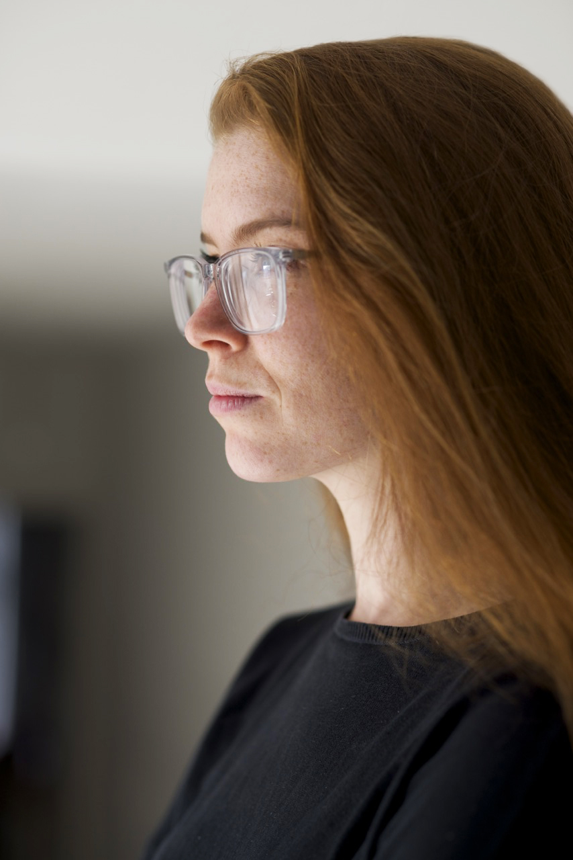
TEN.
gallery director Cat Gardiner

IImage courtesy of TEN, photography by Jon Pountney

Part home gallery, part members club, TEN. is a timely and indicative take on the traditional gallery model.

The TEN. home gallery acts as the hub for gallery exhibitions and couples as a ‘by appointment’ viewing space in-between shows. The gallery also works with its artists, alongside public and private institutions, to host events and off-site exhibitions for its clients and followers that enrich their knowledge and appreciation of contemporary art.

Specialising in contemporary Welsh art and representing some of the very best emerging and established artists, TEN. has gained repute as a trusted foundation for exhibiting and promoting the highest quality contemporary art to both beginner and seasoned collectors.

TEN was established in 2010 by gallerist-curator Cat Gardiner.

